SIMATS ENGINEERING
ASSESSMENT TOOL 1
COURSE NAME:​  COURSE CODE:​ | Database Management Systems
 | CSA05​ | ​ | ​ | ​ | ​
COURSE OUTCOME COVERED
CO1: Analyze DBMS architecture, different data models, schema types, and design ER/EER diagrams, relational schemas for case-based scenarios by identifying entities and relationships. (BL1, BL2)
Activity Tool ​ : Short Answer Text(High)
Assessment Tool Weightage: 40%
QUESTIONS
Q. No | Question | Bloom's Level
1 | Explain schema and instance with examples. Distinguish between logical schema, physical schema, and view schema. | BL1 –  Remember
2 | Identify the entities, attributes, and relationships for a Bank Management System and construct its ER diagram. | BL2 –  Understand
3 | Explain the Extended ER (EER) model. Describe the concepts of generalization, specialization, and aggregation. | BL2 –  Understand
4 | Design an EER diagram for a Hospital Management System incorporating inheritance and weak entities. | BL2 –  Understand
5 | Explain the role of a DBA (Database Administrator) and the responsibilities associated with the position. | BL1 –  Remember

Code of Conduct:
I _____AKCHAYADEVI.G(192524501)_______________ (Name / Reg No) certify that this submission is my original work and that I have adhered to the guidelines specified for this assessment. I understand that any violation of academic integrity rules will result in disciplinary action.
AKCHAYADEVI.G
Signature of the student:
Criteria | Weightag e | Level 4  (Exemplary) | Level 3  (Proficient) | Level 2  (Developing) | Level 1  (Beginning)
Concept  Identification | 30% | Demonstrates  clear and  complete  understanding of the concept | Good  understanding with minor  gaps | Basic  understanding with some  misconception s | Poor or  incorrect  understandin g
Linkages | 25% | Completely  correct answer with no errors | Mostly correct with minor  errors | Partially  correct  with noticeable errors | Incorrect or irrelevant  answer
Organizatio n | 20% | Correctly applies concepts to  solve  the  question/proble  m | Applies  concepts with minor  mistakes | Limited or partially  correct  application | No or  incorrect  application
Integration  of Literature | 15% | Covers all  required parts of the question | Covers most parts with  minor  omissions | Covers only some parts | Incomplete or missing response
Clarity | 10% | Clear, concise, and well-  organized  answer | Understandab l  e with minor issues | Somewhat unclear or poorly  structured | Difficult to  understand
RUBRICS FOR CALCULATION:

Question 1
Explain Schema and Instance with examples. Distinguish between Logical Schema, Physical Schema, and View Schema.

1. Schema
Definition :-
A Schema is the blueprint or overall design of a database. It defines the structure of the database, including tables, attributes (columns), data types, relationships, and constraints. The schema is created during database design and changes very rarely.
Features
- Defines the structure of the database.
- Includes tables, columns, and relationships.
- Does not contain actual data.
- Created by the database designer or DBA.

Example
Suppose we have a Student table.
Schema :-
Column Name | Data Type
Student_ID | INT
Name | VARCHAR(50)
Department | VARCHAR(30)
Age | INT

This table structure is called the schema because it defines how the data will be stored.

2. Instance
Definition
An Instance is the actual data stored in the database at a particular time. The instance changes whenever new records are inserted, updated, or deleted.
Features
- Contains real data.
- Changes frequently.
- Represents the current state of the database.
Example
Using the above Student schema, the instance may be:

Student_ID | Name | Department | Age
101 | jaya | CSE | 20
102 | Priya | ECE | 21
103 | Arjun | IT | 22

If another student is added, the instance changes, but the schema remains the same.

3. Logical Schema
Definition
The Logical Schema describes the logical structure of the database. It specifies what data is stored, the relationships among tables, and constraints, without considering how the data is physically stored.

Example
Student (Student_ID, Name, Department, Age)
Course (Course_ID, Course_Name)
Enrollment (Student_ID, Course_ID)
Here, only the database structure and relationships are defined.

Features
- Defines tables and attributes.
- Specifies relationships among tables.
- Independent of physical storage.
- Used by database designers.
4. Physical Schema
Definition:
A Physical Schema describes how data is physically stored in the database. It includes storage details such as files, indexes, and disk blocks.
Features:
- Describes physical storage of data.
- Includes files and indexes.
- Improves data retrieval speed.
- Managed by the DBMS.
Example:
Student_ID | Name | Department
101 | jaya | CSE
102 | Priya | ECE

Physical Storage:
- File: student.dat
- Index: B+ Tree on Student_ID
- Stored in disk blocks on the hard disk.
5. View Schema
Definition:
A View Schema (External Schema) is the part of the database that is visible to a specific user. It shows only the required data and hides unnecessary or confidential information.

Features:
- Shows only required data.
- Hides sensitive information.
- Improves security.
- Different users can have different views.
Example:
Student_ID | Name | Marks | Attendance
101 | jaya | 85 | 90%

Difference Between Logical Schema, Physical Schema, and View Schema
Logical Schema | Physical Schema | View Schema
Defines the logical structure of the database. | Defines how data is physically stored. | Defines what data a specific user can access.
Contains tables, attributes, and relationships. | Contains storage details, files, and indexes. | Contains only selected data.
Independent of storage devices. | Depends on storage devices. | Depends on user requirements.
Used by database designers. | Used by DBMS and DBAs. | Used by end users and applications.
Example: Student(Student_ID, Name, Age). | Example: Records stored using B+ Tree index. | Example: Student sees only Name and Department.

Conclusion
A schema defines the structure of a database, while an instance represents the actual data stored at a particular time. The Logical Schema defines the database structure, the Physical Schema describes how data is stored internally, and the View Schema provides customized views for different users. Together, these schemas provide data abstraction, security, and efficient database management.

Question 2
Draw an ER Diagram for a Bank Management System. Identify entities, attributes, relationships, and cardinality.

Introduction
A Bank Management System stores and manages information about customers, accounts, loans, branches, employees, and transactions. An Entity-Relationship (ER) Diagram represents the entities, their attributes, relationships, and cardinality.

1. Entities and Attributes
Customer
- Customer_ID (Primary Key)
- Name
- Address
- Phone
Account
- Account_No (Primary Key)
- Account_Type
- Balance
Branch
- Branch_ID (Primary Key)
- Branch_Name
- Location
Loan
- Loan_ID (Primary Key)
- Loan_Amount
- Interest_Rate
Employee
- Employee_ID (Primary Key)
- Name
- Designation
Transaction
- Transaction_ID (Primary Key)
- Date
- Amount
- Type

2. Relationships
- Customer owns Account.
- Branch maintains Account.
- Customer applies for Loan.
- Employee works at Branch.
- Account performs Transaction.

3. Cardinality
Relationship | Description | Cardinality
Customer – Account | A customer can own one or more bank accounts. | 1 : M (One-to-Many)
Branch – Account | A branch maintains multiple accounts. | 1 : M (One-to-Many)
Customer – Loan | A customer can apply for one or more loans. | 1 : M (One-to-Many)
Branch – Employee | A branch has many employees working in it. | 1 : M (One-to-Many)
Account – Transaction | An account can have many transactions. | 1 : M (One-to-Many)

4. ER Diagram (Simple)
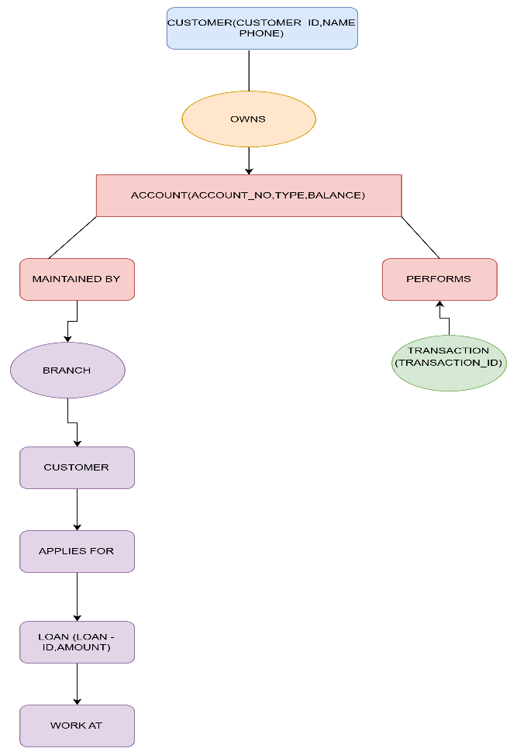

Conclusion
The ER Diagram of a Bank Management System includes Customer, Account, Branch, Loan, Employee, and Transaction as the main entities. Their relationships and cardinalities help organize the database efficiently, ensuring proper management of banking operations.

Question 3
Explain the Extended Entity-Relationship (EER) Model. Discuss the concepts of Generalization, Specialization, and Aggregation with examples.

Introduction
The Extended Entity-Relationship (EER) Model is an advanced version of the Entity-Relationship (ER) Model. It provides additional features such as Generalization, Specialization, and Aggregation to represent complex real-world applications more effectively.

1. Generalization
Definition
Generalization is the process of combining two or more similar lower-level entities into a single higher-level entity based on their common attributes.
Features
- Combines similar entities.
- Creates a common parent entity.
- Reduces data redundancy.
Example
Savings Account
\
\
Account
/
Current Account

Here, Savings Account and Current Account are generalized into the Account entity.

2. Specialization
Definition
Specialization is the process of dividing one higher-level entity into multiple lower-level entities based on specific characteristics.

Features
- Divides a parent entity into child entities.
- Child entities inherit attributes from the parent.
- Adds specialized attributes.

Example
Employee
/ \
Manager Clerk

Here, Employee is specialized into Manager and Clerk.

3. Aggregation
Definition
Aggregation is a process in which a relationship between entities is treated as a higher-level entity so that it can participate in another relationship.
Features
- Treats a relationship as an entity.
- Represents complex relationships.
- Simplifies database design.
Example
Customer
|
Places
|
Order -------- Product

Here, the Order relationship is treated as a higher-level entity connected to Product.

Conclusion
The EER Model extends the ER model by supporting Generalization, Specialization, and Aggregation. These concepts help represent complex database structures more accurately and improve database design.

Question 4
Design an EER Diagram for a Hospital Management System incorporating inheritance and weak entities.
Introduction
A Hospital Management System (HMS) is used to manage information about patients, doctors, nurses, rooms, bills, records, and test reports. The Extended Entity Relationship (EER) model represents these entities, their relationships, inheritance, and weak entities.

Hospital Management System EER Diagram

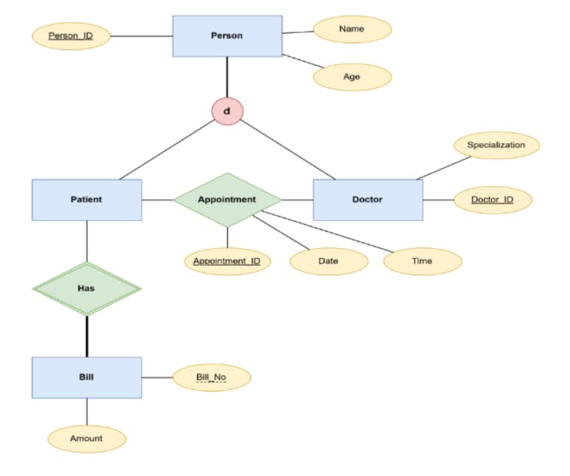

Explanation of the Hospital Management System EER Diagram
The Hospital Management System EER diagram represents the entities, attributes, relationships, inheritance, and weak entities involved in managing hospital operations.

1. Patient Entity
The Patient entity stores patient details such as P-ID, Name, Age, Gender, Date of Birth (DOB), and Mobile Number. A patient can consult doctors, pay bills, have test reports, and be assigned to a room.
2. Employee Entity (Super Entity)
The Employee entity is the superclass and contains common attributes like E-ID, Name, Salary, Address, Mobile Number, and Sex.
3. Inheritance (Specialization)
The Employee entity is specialized into three subclasses:
- Doctor – Attributes: Department, Qualification
- Nurse
- Receptionist
These subclasses inherit the common attributes of the Employee entity.
4. Room Entity
The Room entity contains R-ID, Type, Capacity, and Availability. Patients are assigned to rooms, and nurses govern the rooms.
5. Bills Entity
The Bills entity stores billing information such as B-ID, Amount, and P-ID. Each patient pays one or more bills.
6. Test Report (Weak Entity)
The Test Report stores Test Type, Result, P-ID, and R-ID. It depends on the Patient entity for its existence, making it a weak entity.
7. Records Entity
The Records entity stores Record Number and Appointment Number. These records are maintained by the receptionist.
8. Relationships
- Patient consults Doctor (M:N)
- Patient pays Bills (1:N)
- Patient has Test Reports (1:N)
- Patient is assigned to a Room (N:1)
- Nurse governs Rooms (M:M)
- Receptionist maintains Records (M:M)

Conclusion
This EER diagram models the hospital database efficiently by using inheritance (Employee → Doctor, Nurse, Receptionist) and a weak entity (Test Report). It helps organize patient, employee, room, billing, and medical record information effectively.

Question 5
Explain the role of a DBA (Database Administrator) and the responsibilities associated with the position.

Introduction
A Database Administrator (DBA) is a person responsible for managing, maintaining, and securing a database. The DBA ensures that the database operates efficiently, remains secure, and is available to authorized users.
Definition
A Database Administrator (DBA) is a professional who installs, configures, maintains, and monitors databases to ensure data is stored securely and can be accessed efficiently.

Role of a DBA
- Manages the database system.
- Ensures database security.
- Maintains database performance.
- Performs backup and recovery.
- Controls user access and permissions.

Responsibilities of a DBA
- Database Installation and Configuration
  - Installs and configures DBMS software.
- Database Design
  - Creates database structures, tables, and relationships.
- Security Management
  - Protects data from unauthorized access.
- User Management
  - Creates user accounts and assigns permissions.
- Backup and Recovery
  - Performs regular backups and restores data after failures.
- Performance Monitoring
  - Monitors and improves database performance.
- Data Integrity
  - Ensures data is accurate, consistent, and reliable.
- Database Maintenance
  - Updates, patches, and maintains the database.
Advantages of a DBA
- Ensures data security.
- Improves database performance.
- Prevents data loss through backups.
- Maintains data consistency and availability.

Conclusion
A Database Administrator (DBA) plays a vital role in managing and maintaining databases. The DBA is responsible for database security, backup, recovery, performance optimization, and user management, ensuring that the database remains reliable, secure, and efficient.

